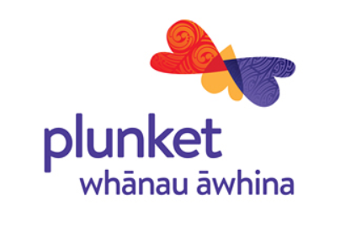
Agreement for the provision of Plunket provided MSD approved Youth Service Parenting course between Royal New Zealand Plunket Trust, The Provider and The Youth Service Provider.

Registration Form 2026 Youth Service Parenting Online delivery
Youth Service Name
Participant Name for certificate | Preferred Name if known | Child age | Preferred pronoun if known | Participant email address (required )

Price $220 per person Main course  (Prices are excluding gst) | Total  Invoice  Invoice will be sent upon registration acceptance | Course Dates:
Youth Service contact name |  | Contact Details

Youth Service responsibilities:
- Encourage and remind students of upcoming course
- Facilitate participants to attend course with a suitable device for Microsoft Teams (smartphone or computer) and ensure data to complete course.
- Are responsible for any additional costs such as travel, data or extra incentives.

Cancellation Policy:

- Invoicing occurs once a participant attends the first day of a course.
- If a student completes day one, but for some reason cannot attend day 2 they can complete day 2 at the next course or complete online learning modules for day 2.

